

**Lab 03**

**Lab Title: Working with Git History, Stashing, and Reverting Commits**

**Submitted to: Engr. Muhammad Shoaib**

**Submitted by: Anara Hayat**

**Reg#No: 2023-BSE-008**

**1.Open your repository on GitHub and edit the README.md file directly in the browser.**

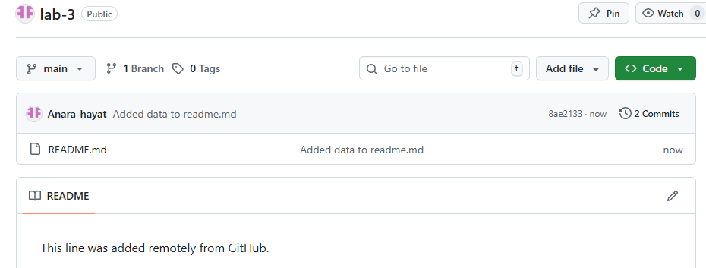

**2.On your local machine, open the same repository folder.**

* **Edit the same README.md file locally**
* **Stage and commit your changes**

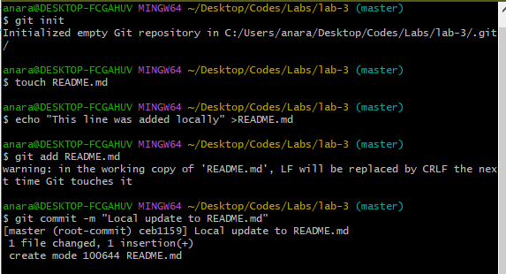

* **Try to push**

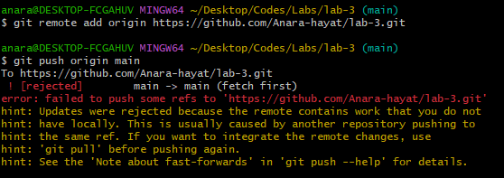

* **To fix this, pull the latest changes from remote:**

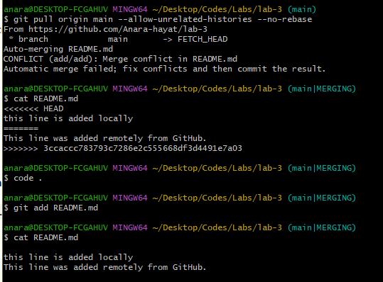

* **Push again:**

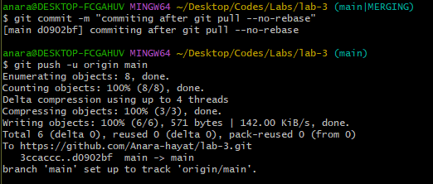

* **Now repeat the same process, but this time use rebase instead of merge**

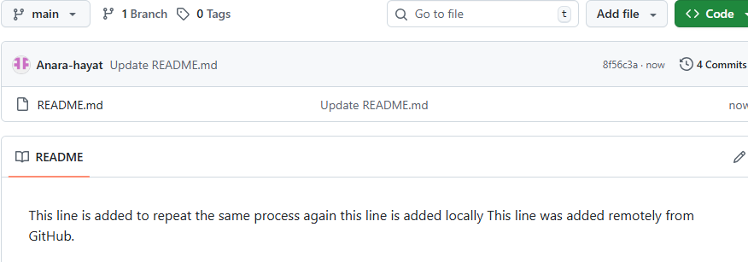

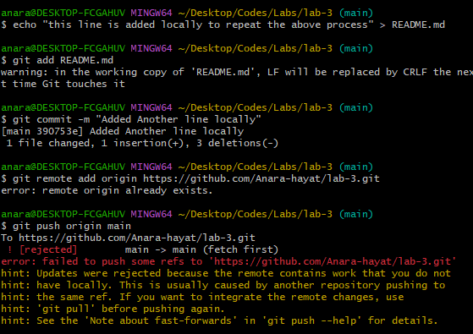

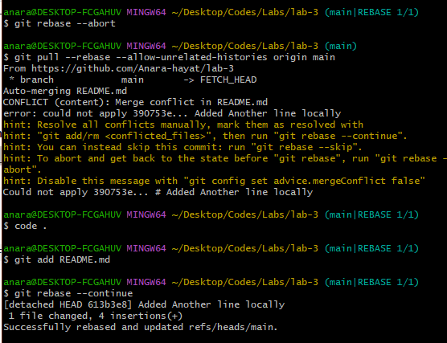

**Push:**

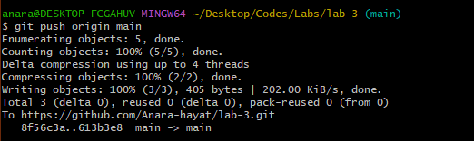

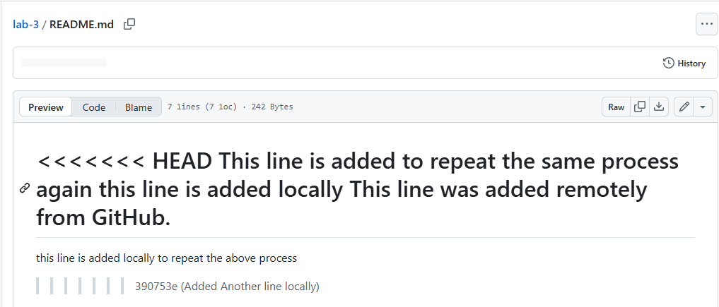

**Task 2 – Creating and Resolving Merge Conflicts Manually**

**Steps**

1. **On GitHub (remote), open your README.md file and change an existing line.**
2. **Commit your change with the message: *Remote conflicting change***

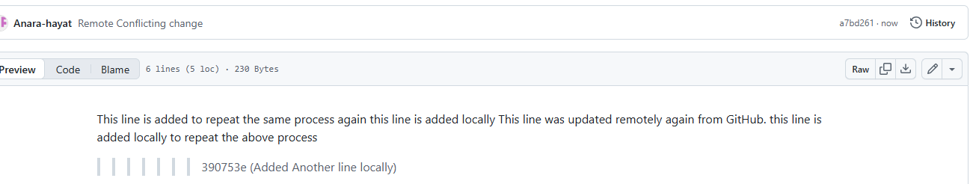

**On your local machine, edit the same line in the same file but make a different change**

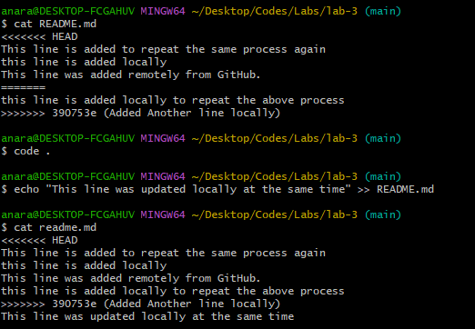

**Stage and commit your local change:**

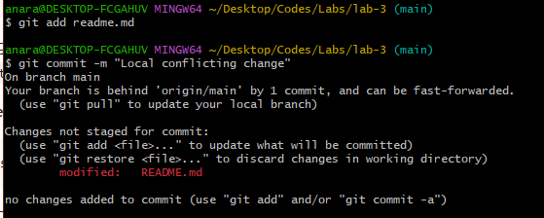

**Try to push:**

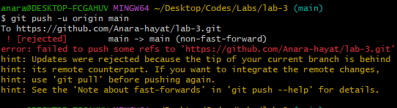

**Pull with rebase to bring in remote changes:**

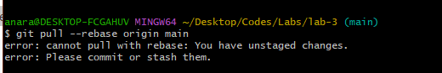

**Open the README.md file in your editor — you’ll see conflict markers like this**

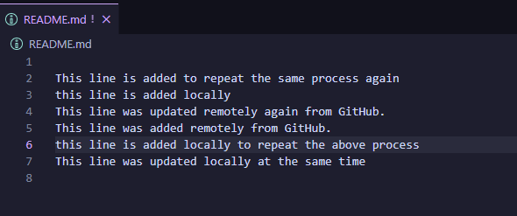

**After fixing the file, mark the conflict as resolved and continue the rebase**

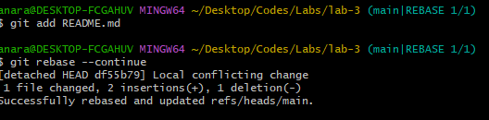

**Finally, push your changes:**

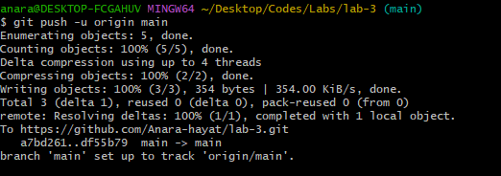

**Task 3 – Managing Ignored Files with .gitignore and Removing Tracked Files**